Joy Mago

MySQL practice worksheet using the adventureworks_customers database to perform different SQL queries.

Portfolio Assignment in MySQL

1. Write a query to find all customers with the first name 'John'.



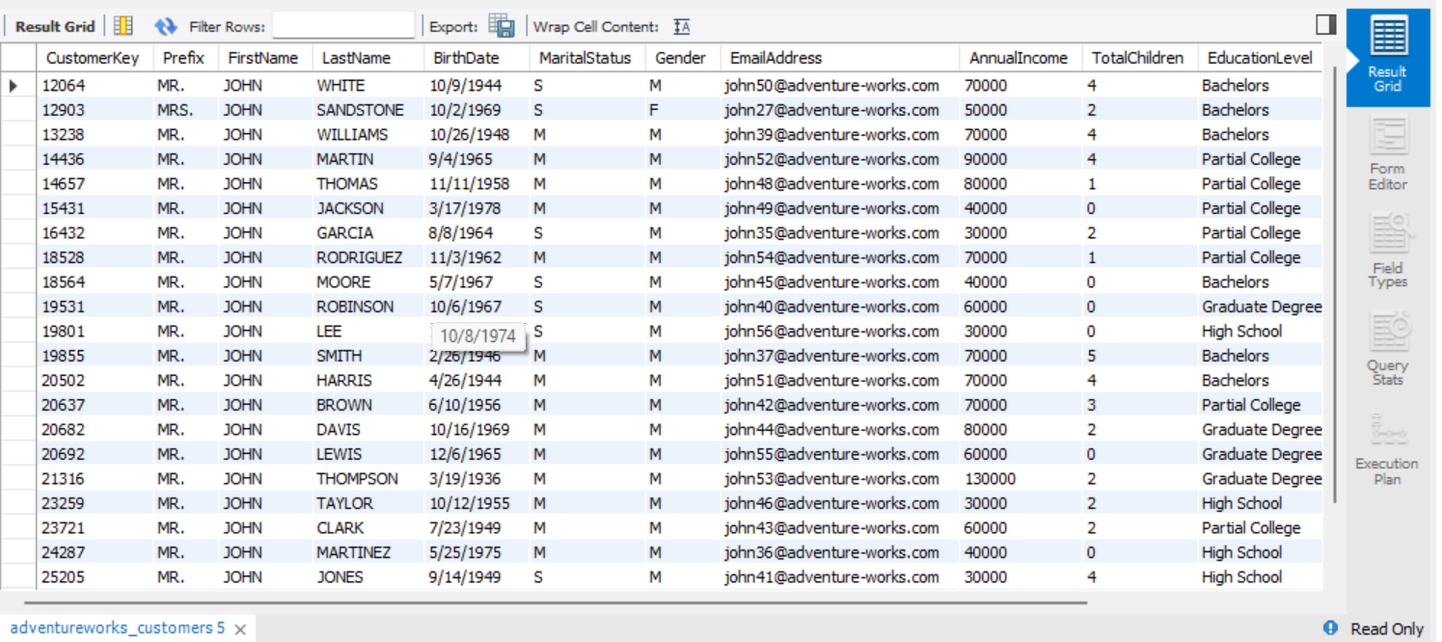

1. Create a query to sort customers alphabetically by their last name in ascending order.

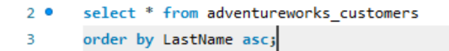

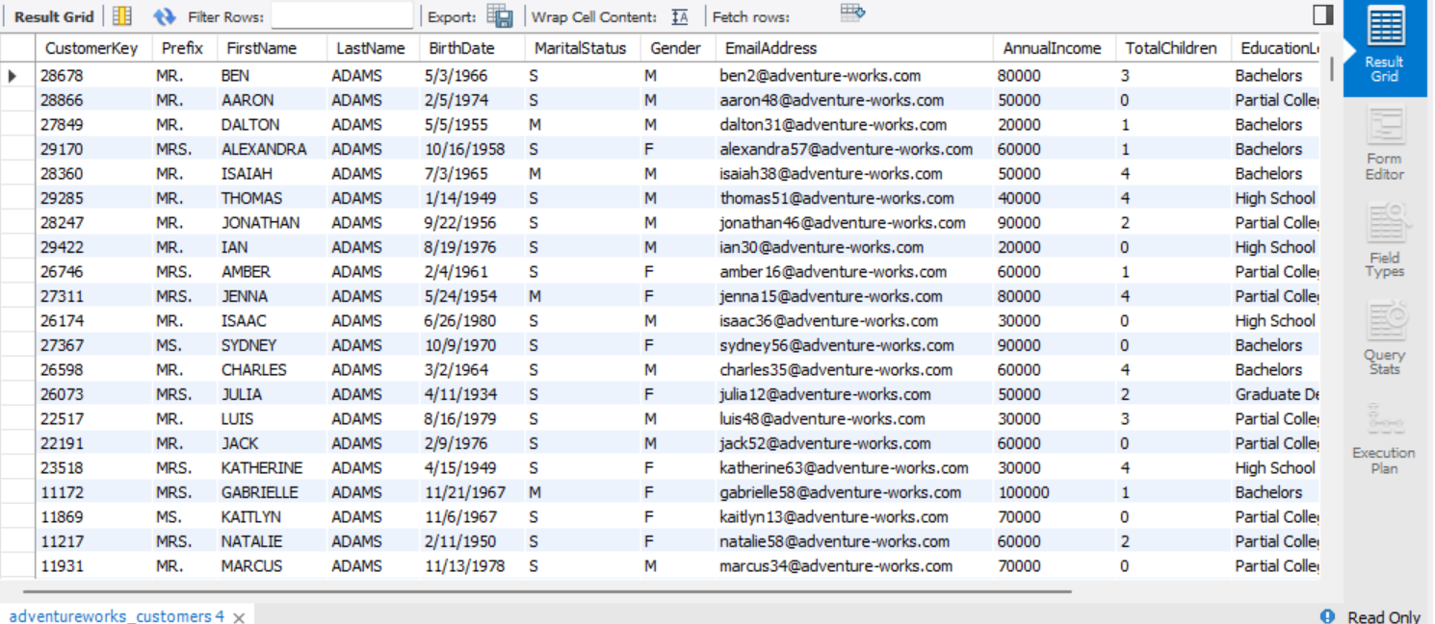

1. Write a query that updates the email address of a customer with CustomerKey 12345 to 'newemail@example.com'.

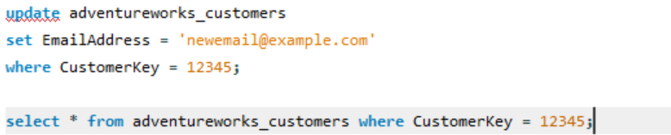



1. Create a query to calculate the average annual income of customers.



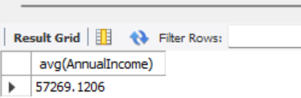

1. Write a query to find customers who were born in the year 1980.



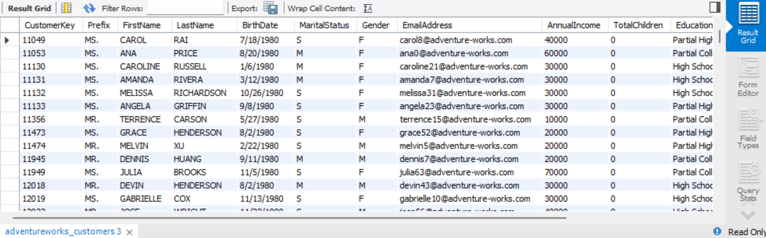

1. Create a query that counts the number of customers with a specific marital status (e.g., Single).

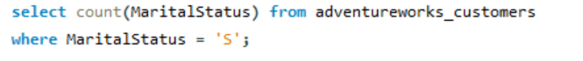

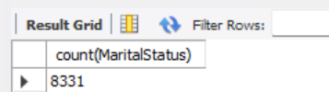

1. Write a query to update the marital status of customers with a specific prefix (e.g., Mr.) to 'Married'.

*Update adventureworks_customers, Set MaritalStatus = ‘Married’, Where Prefix = ‘MR.’;*

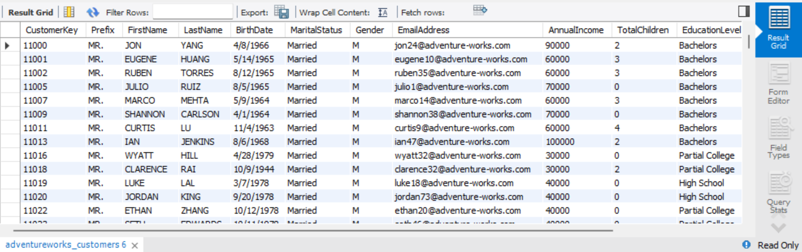

1. Create a query to calculate the total number of customers with a specific education level (e.g., Bachelor's degree).



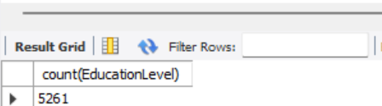

1. Write a query that counts the number of customers in each occupation category.

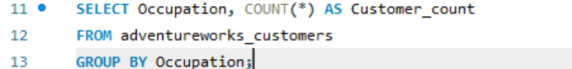

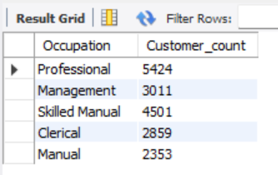

1. Create a query to find the oldest customer in the dataset based on their birthdate.

Due to the Birthdate column being in Text format,

Added a new column for the new date format:

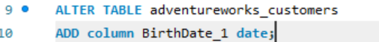

Updated the new column in date format:



Below query showing oldest customer:





1. Write a query to find customers who have at least two children.

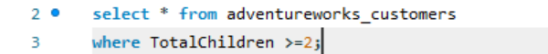

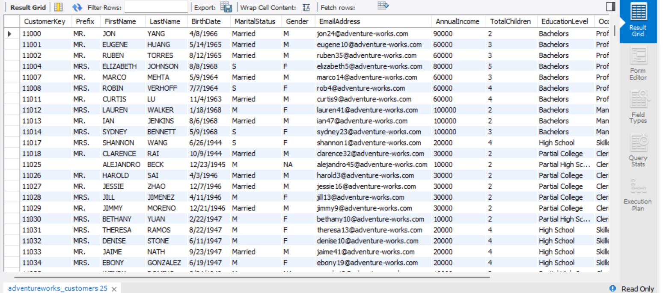

1. Create a query that calculates the sum of annual income for customers with a specific gender (e.g., Male).

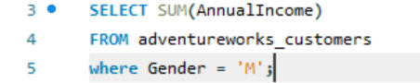

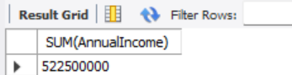

1. Write a query to find customers with an annual income between $50,000 and $100,000.

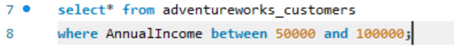

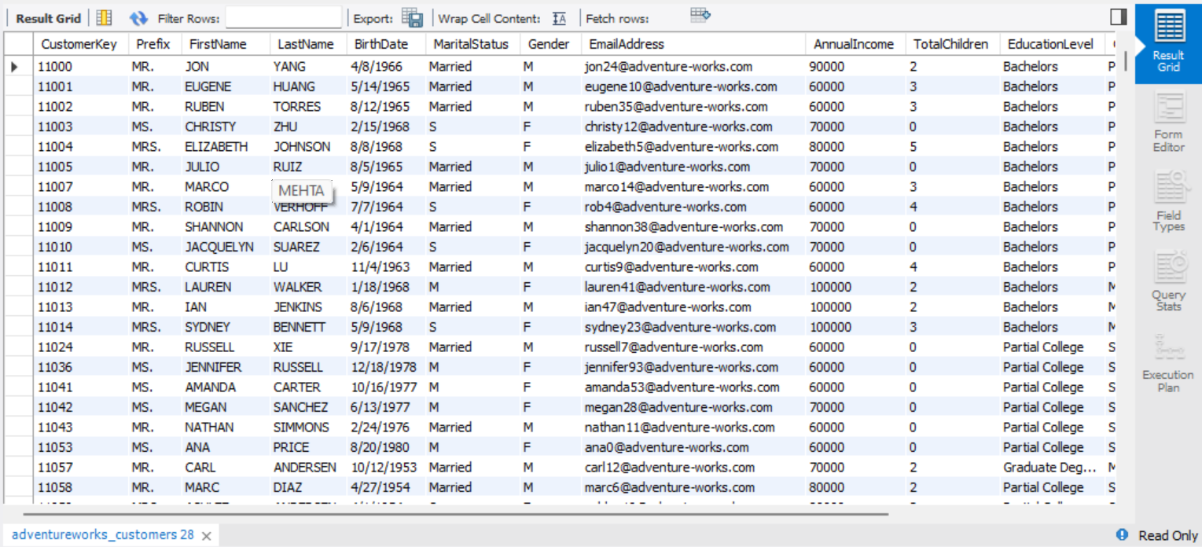

1. Create a query that extracts the first three characters of the first name for each customer.



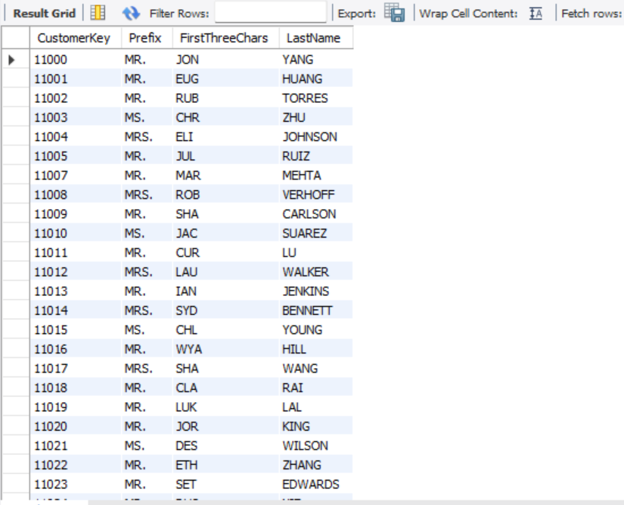

1. Write a query to find customers with a specific prefix (e.g., Dr.) and a specific education level (e.g., Master's degree).



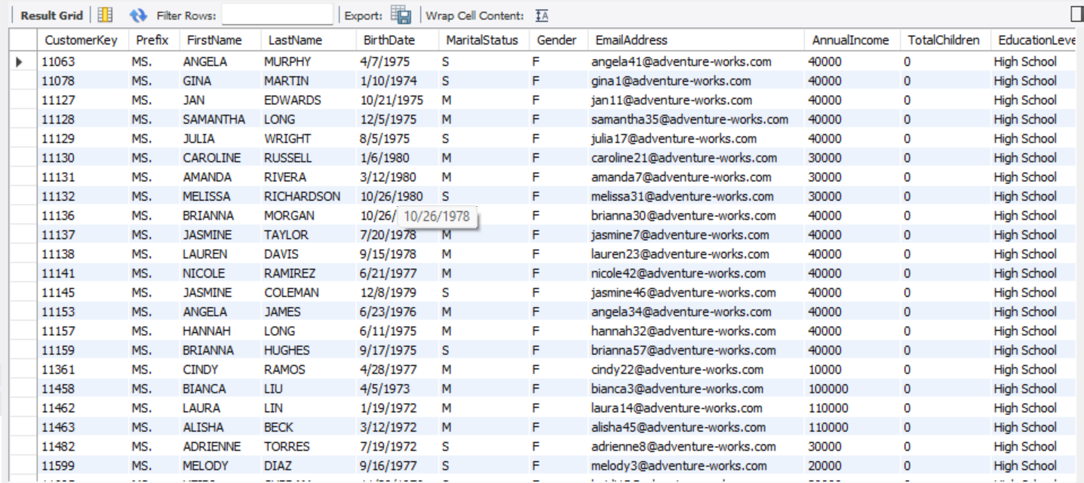

1. Create a query to count the number of customers in each gender category.

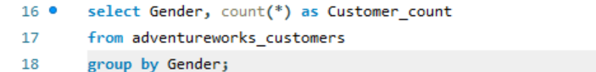

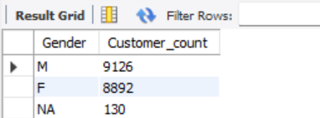

1. Write a query that updates the prefix of all customers with CustomerKey greater than 10000 to 'Ms.'.

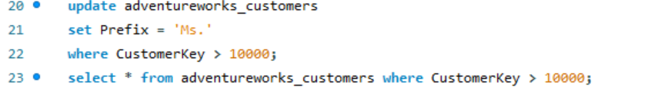

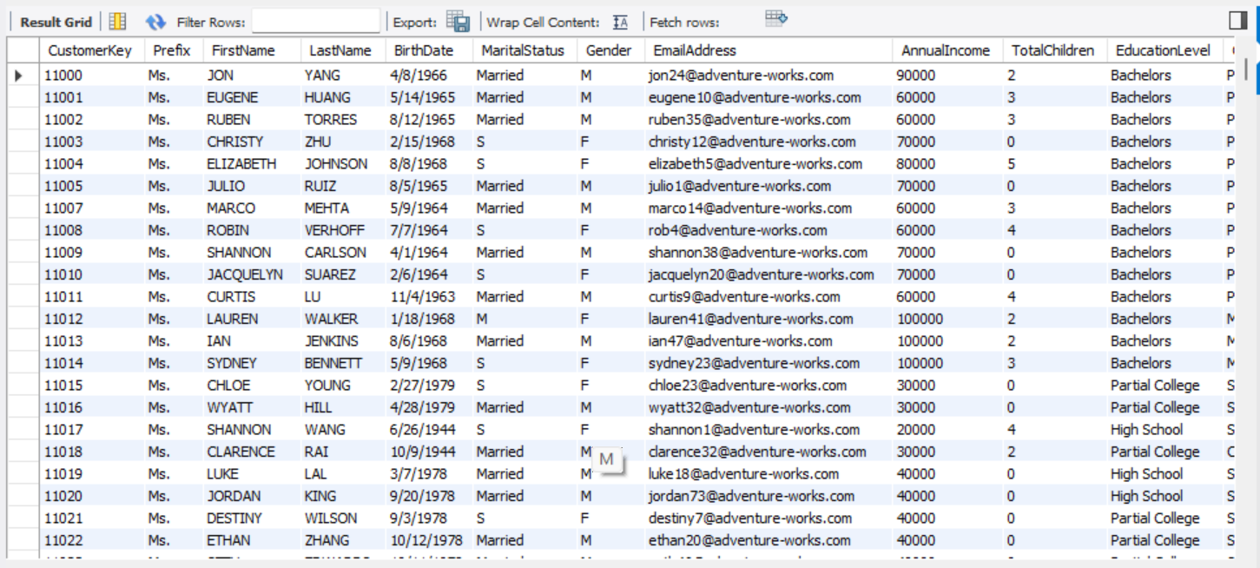

1. Create a query to find the average age of customers with a specific annual income range (e.g., $75,000 - $100,000).

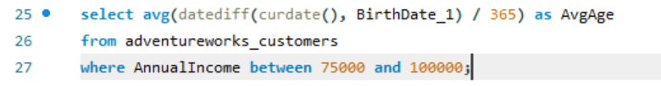

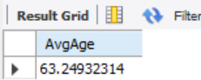

1. Write a query to find customers who were born on a specific day of the week (e.g., Monday).



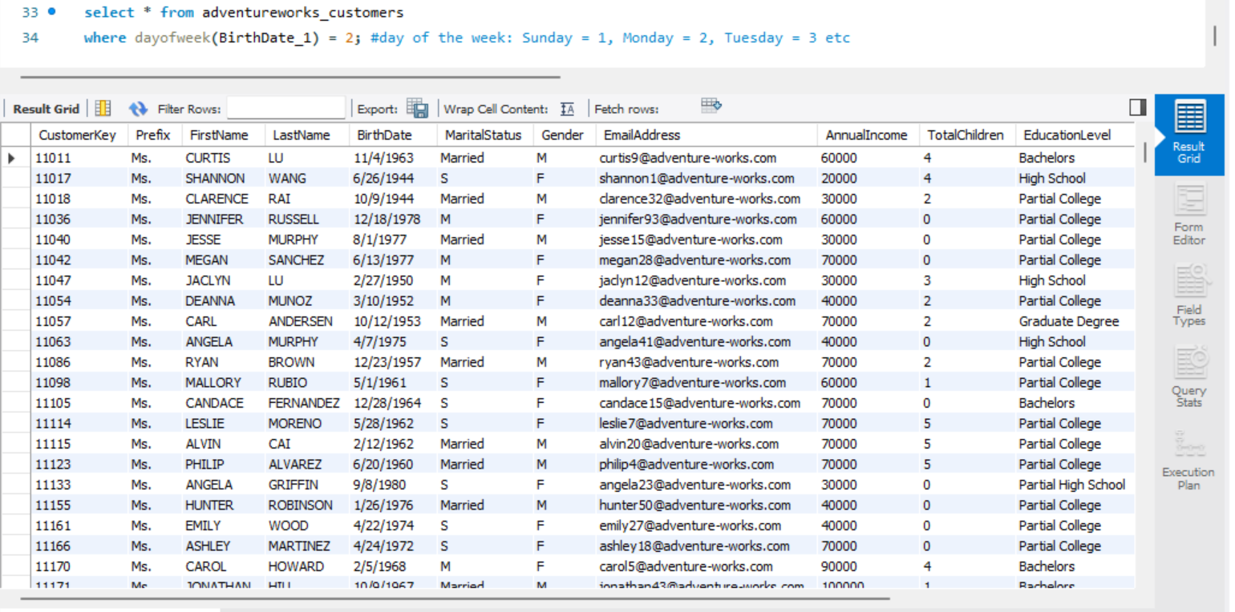

1. Create a query that identifies customers who have not provided their email address.

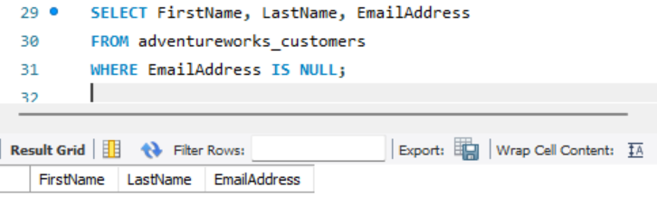

1. Write a query to find customers with an odd-numbered CustomerKey.



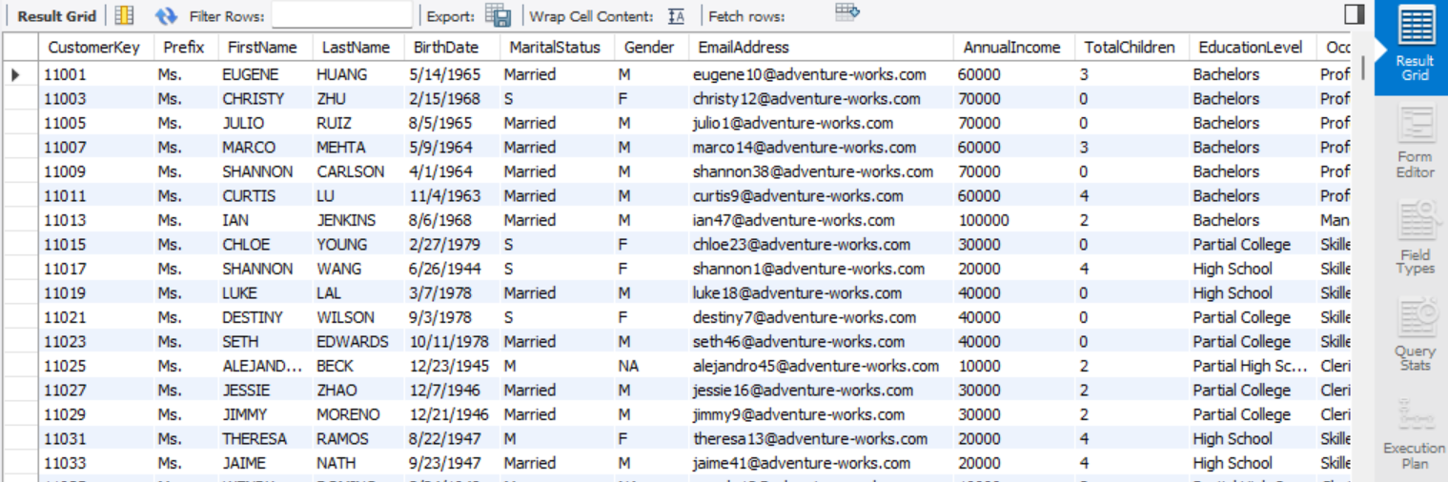

1. Create a query to calculate the average annual income of customers with a specific occupation (e.g., Engineer).

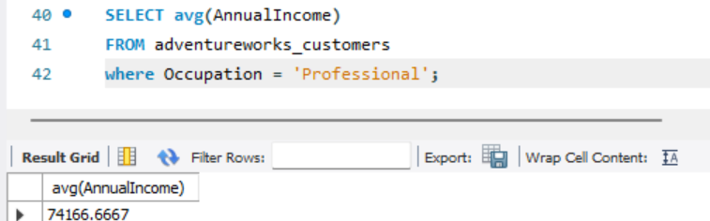

1. Write a query to find the customer with the highest annual income.

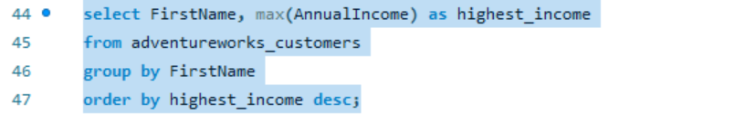

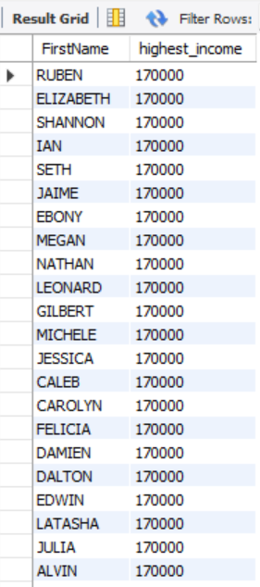

1. Create a query that sorts customers by their annual income in descending order.

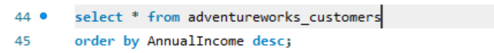

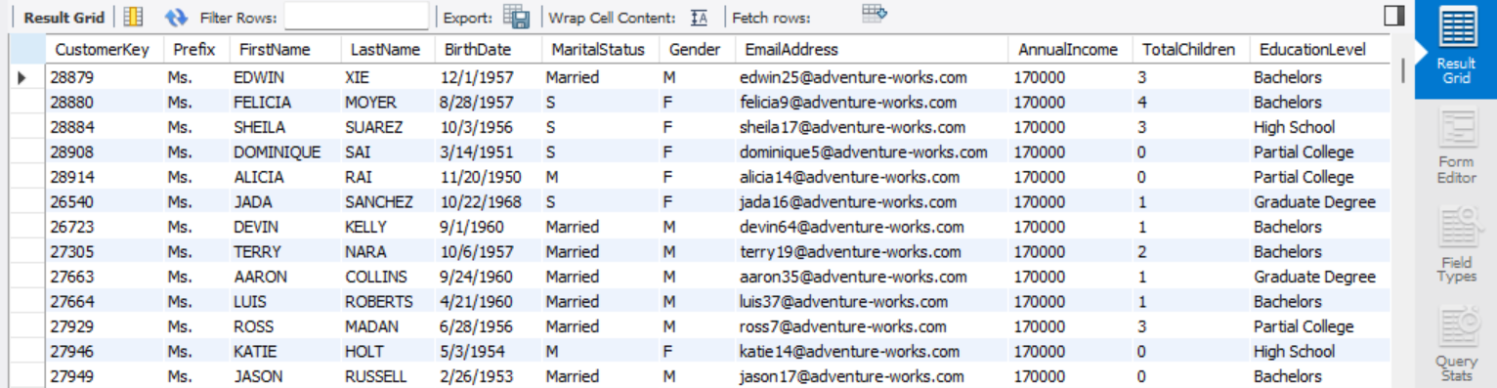

1. Write a query to find customers with a specific suffix in their email address (e.g., @gmail.com).

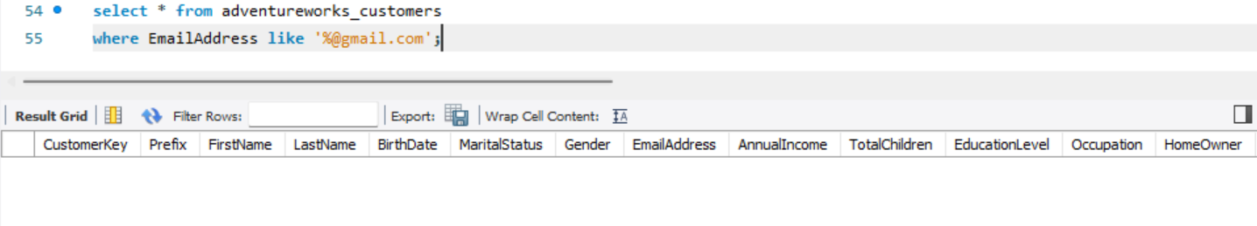

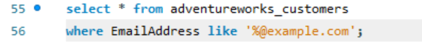



1. Create a query to calculate the total number of customers in the dataset.

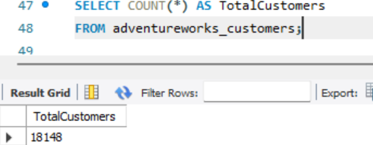

1. Write a query that calculates the number of customers with each marital status within a specific gender group (e.g., Male).

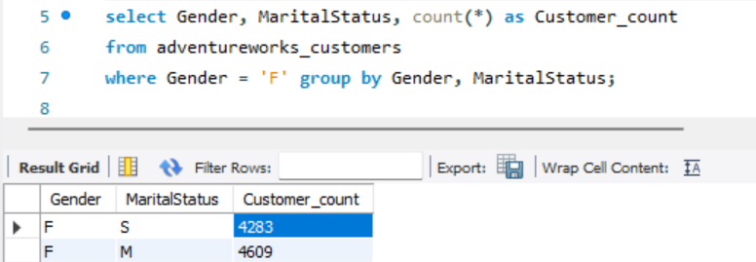

1. Create a query to find customers whose first name contains a specific letter (e.g., 'a').



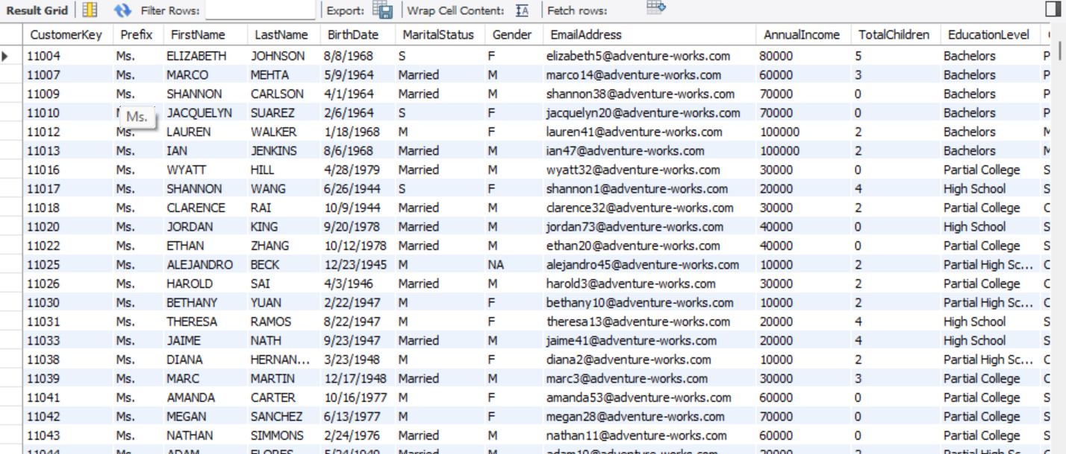

1. Write a query to count the number of customers with an even-numbered CustomerKey.

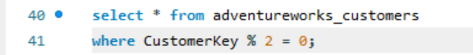

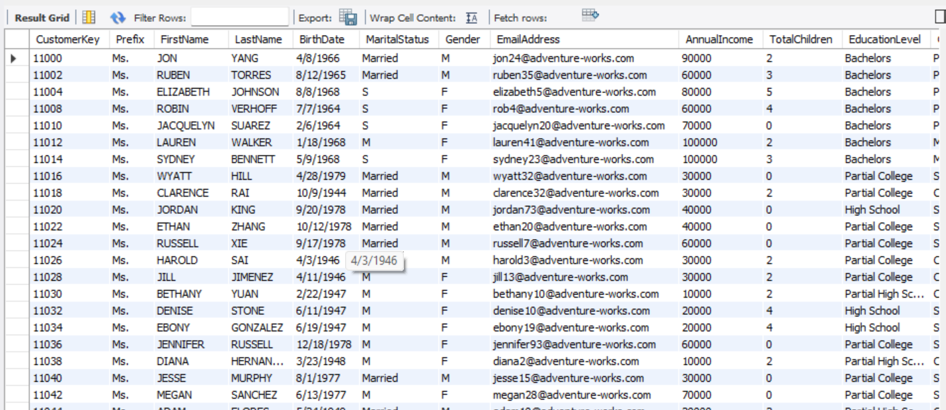

1. Create a query to find customers who were born in a specific month (e.g., May).



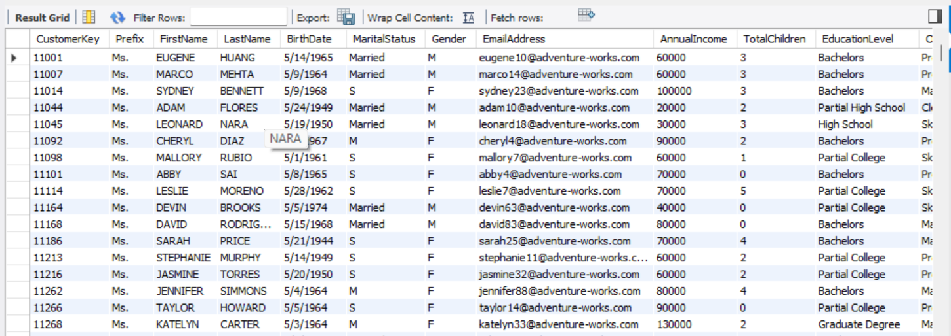

1. Write a query to find customers with a specific occupation and a specific education level.



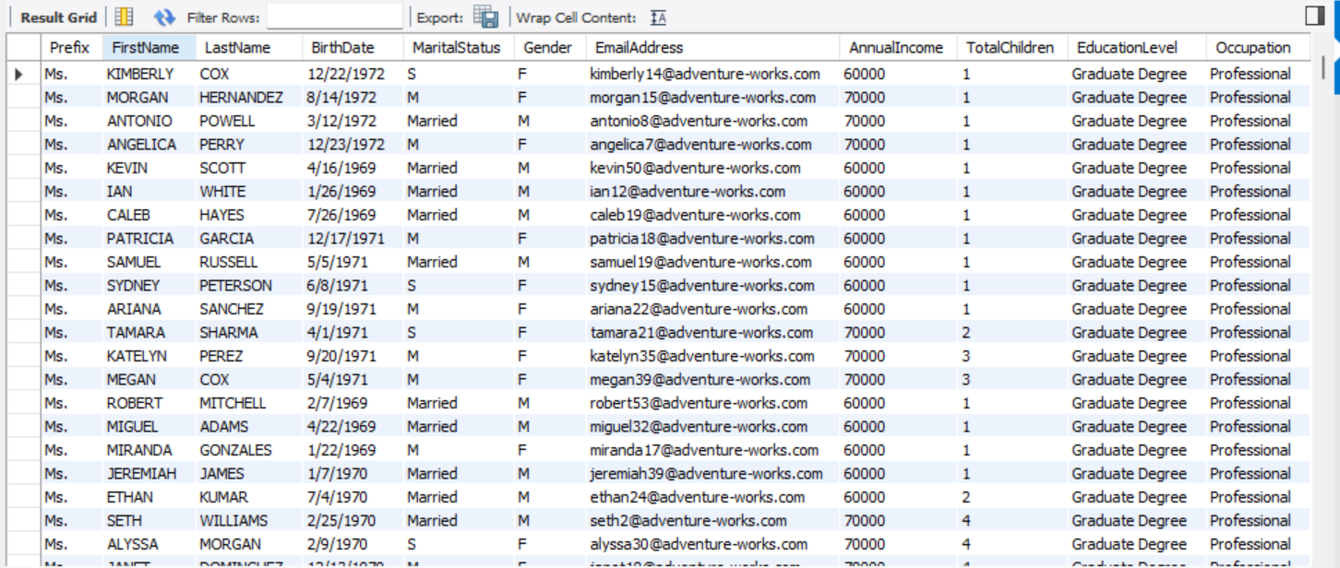

1. Create a query that finds the customer with the lowest annual income.



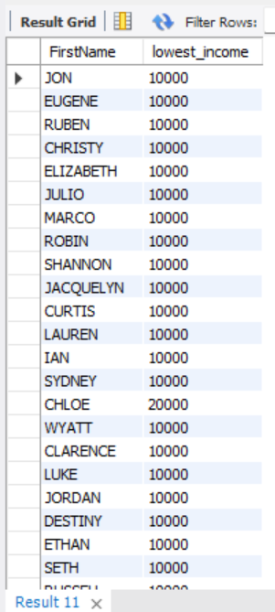

1. Write a query to sort customers by their birthdate in descending order.

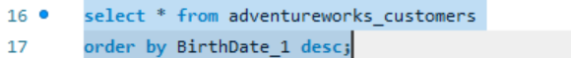

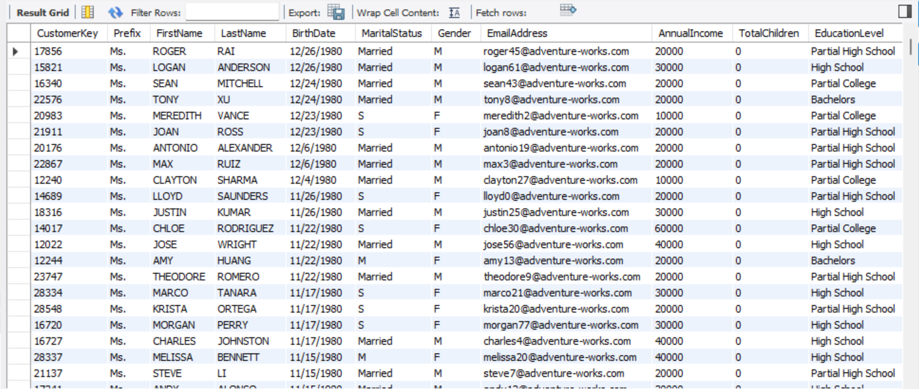

1. Create a query that counts the number of customers with each occupation within a specific annual income range (e.g., $50,000 - $75,000).

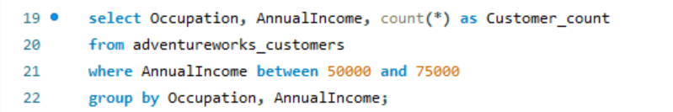

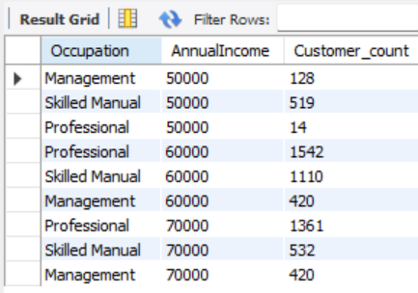

1. Write a query to find customers whose last name starts with a specific letter (e.g., 'S').



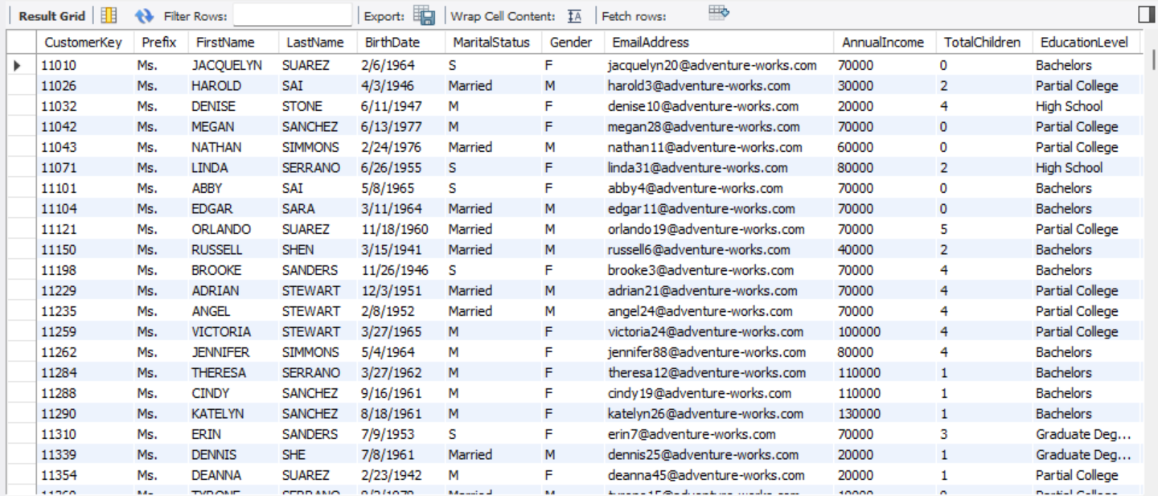

1. Create a query to calculate the total annual income of customers with a specific marital status (e.g., Married).



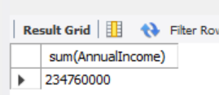

1. Write a query that updates the first name of a specific customer to 'Jane'.

Resul before query is run:



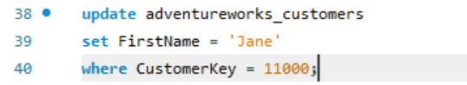

Result after query:



1. Create a query to find customers who were born before a specific year (e.g., 1990).

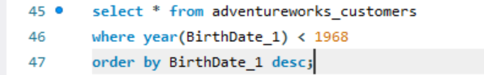

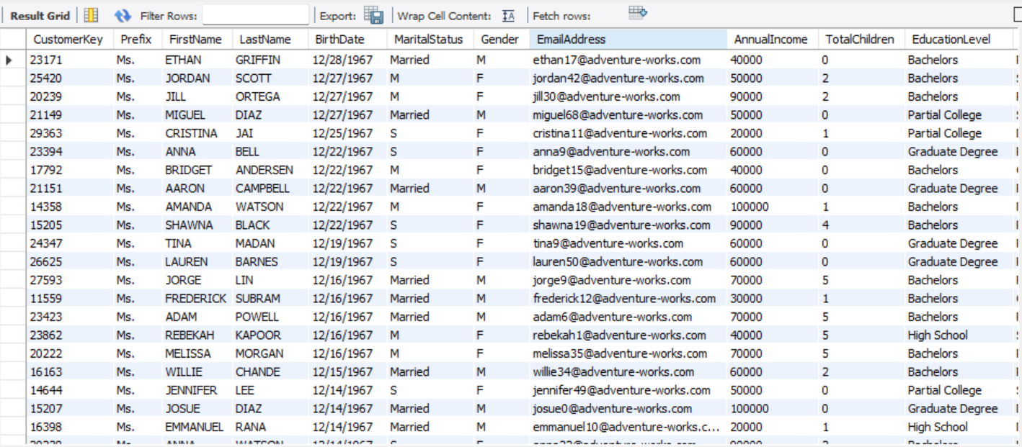

1. Write a query to calculate the number of customers in each education level category.

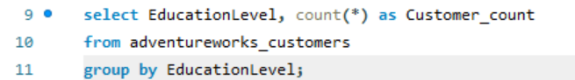

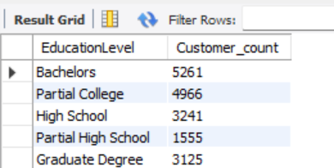

1. Create a query that counts the number of customers with each gender within a specific occupation (e.g., Manager).

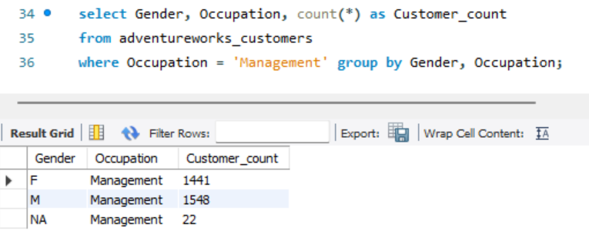

1. Write a query to find customers with a specific first name and last name combination (e.g., John Smith).





1. Create a query to identify customers who have provided their email address.

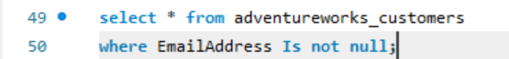

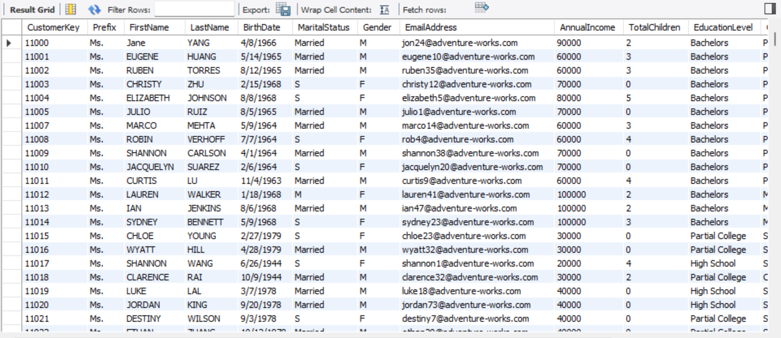

1. Write a query to calculate the average annual income of customers with a specific marital status and gender combination (e.g., Married and Female).

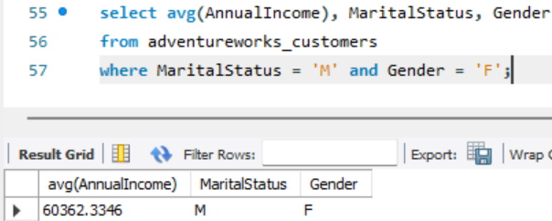

1. Create a query to find customers with an annual income that is a multiple of 10,000.



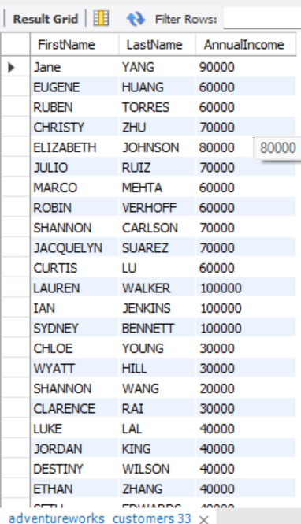

1. Write a query to sort customers by their total number of children in ascending order.

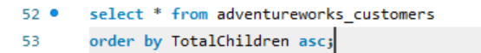

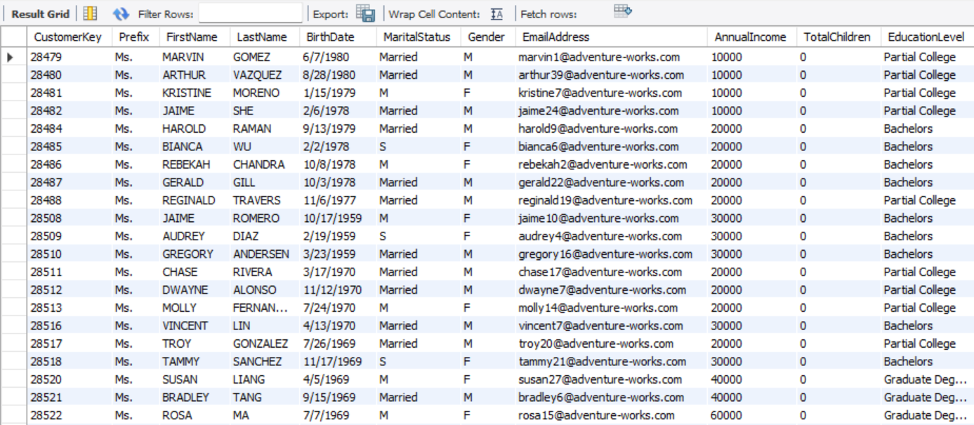

1. Create a query to find customers whose first name starts with a vowel.

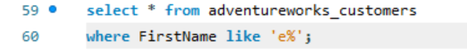

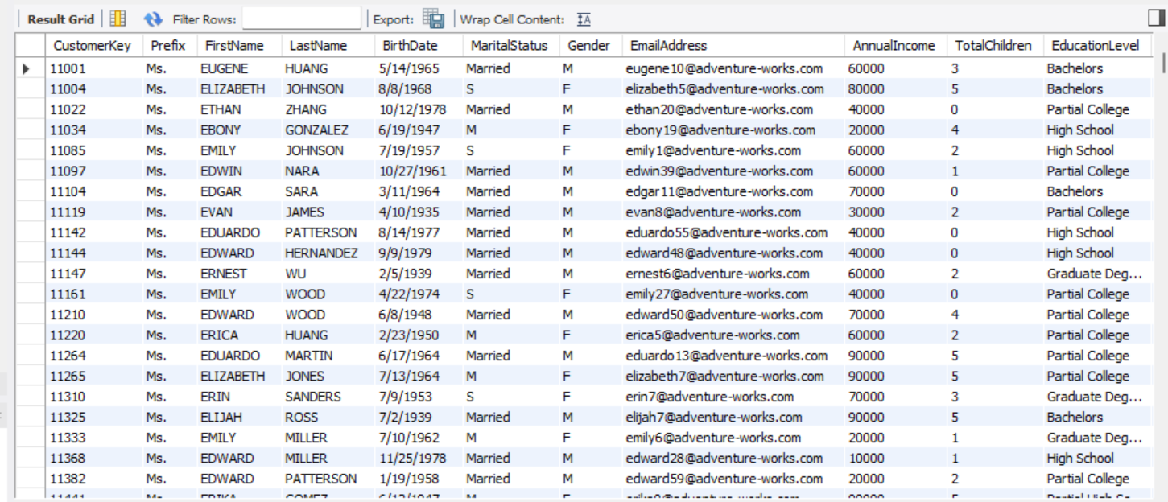

1. Write a query to calculate the average age of customers with a specific occupation and education level combination (e.g., Engineer and Bachelor's degree).

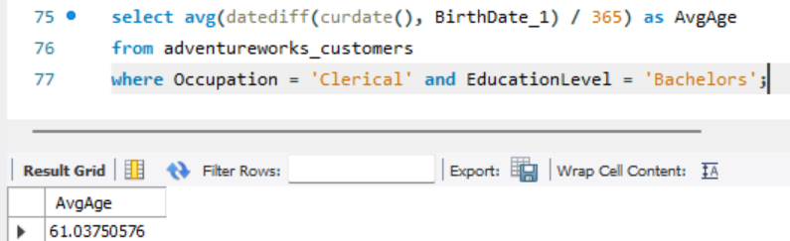

1. Create a query to find customers who were born after a specific year (e.g., 2000).

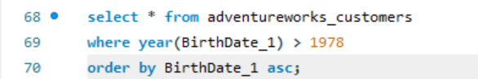

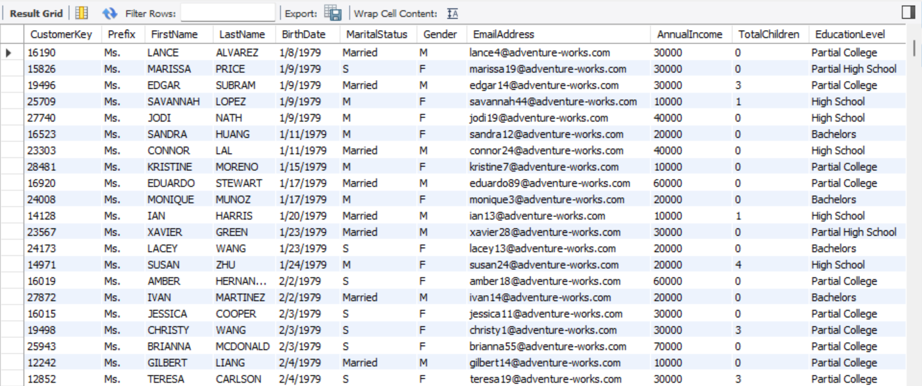

1. Write a query to identify customers with a specific number of children (e.g., 3).

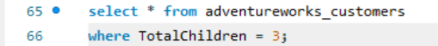

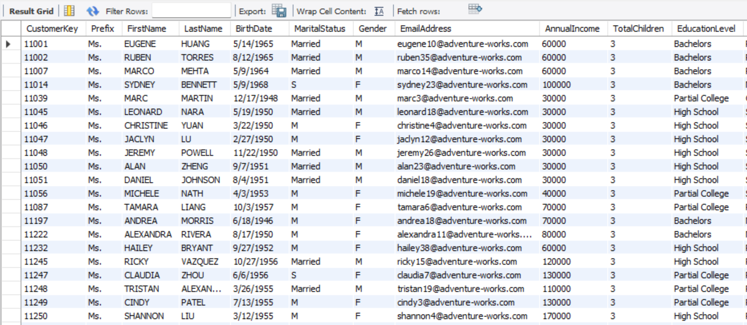

1. Create a query to count the number of customers with a specific email domain (e.g., @yahoo.com).

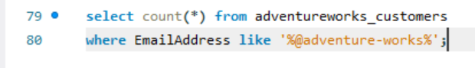

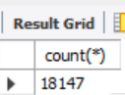

1. Write a query to find customers whose annual income is within a specific range (e.g., $50,000 - $75,000).



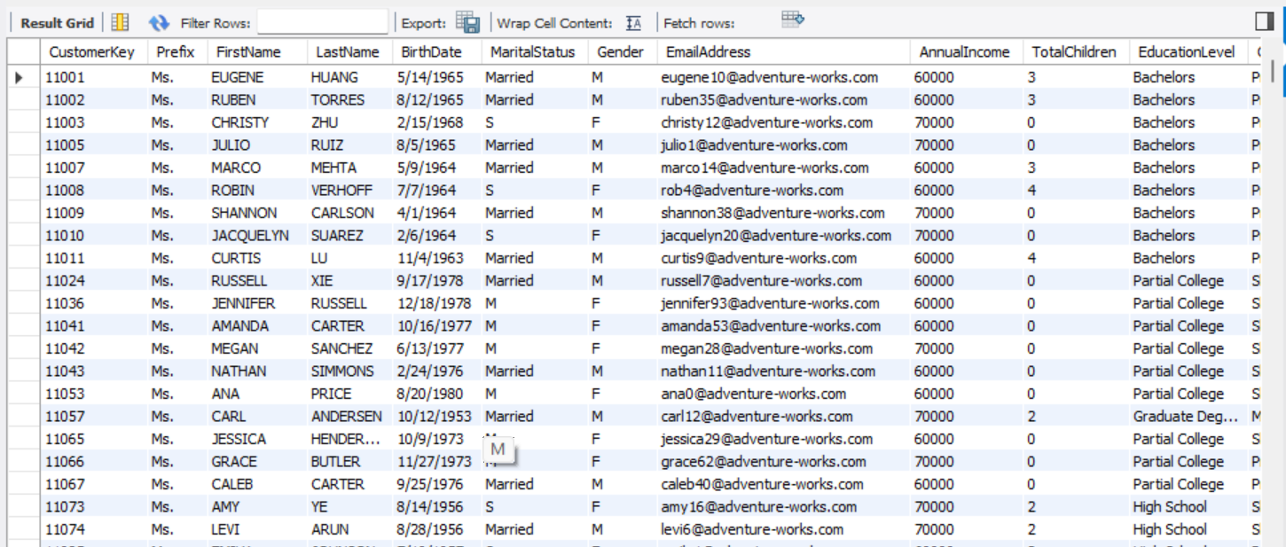

1. Create a query to sort customers by their email address in ascending order.

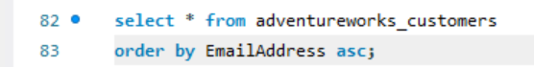

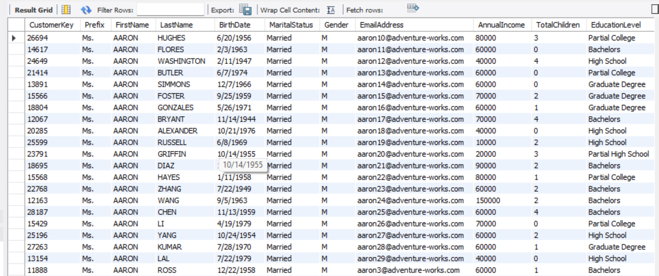

1. Write a query to find customers with an annual income that ends with a specific digit (e.g., 5).

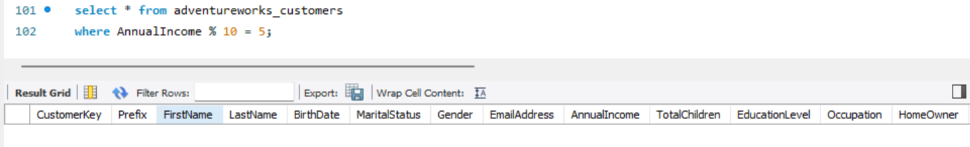

1. Create a query to calculate the total number of customers with a specific marital status and gender combination (e.g., Single and Male).

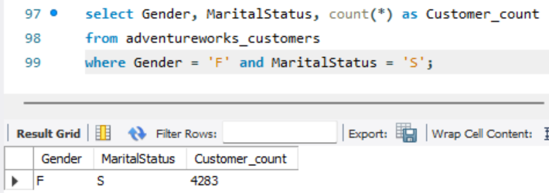

1. Write a query to find customers whose last name contains a specific substring (e.g., 'son').



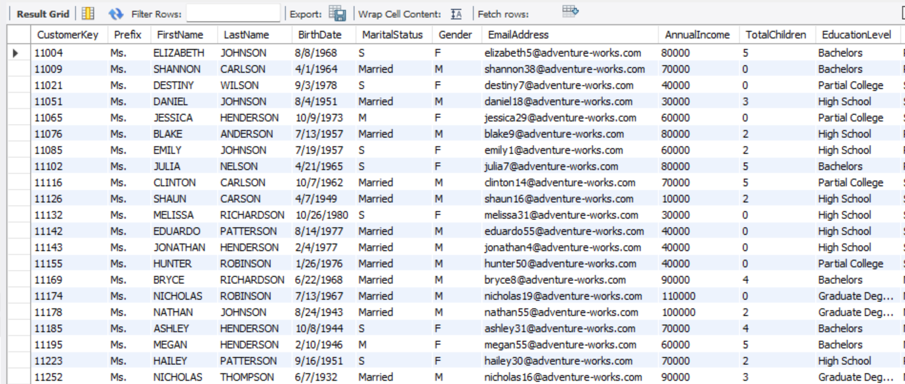

1. Create a query to identify customers who have provided their birthdate.

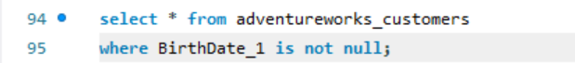

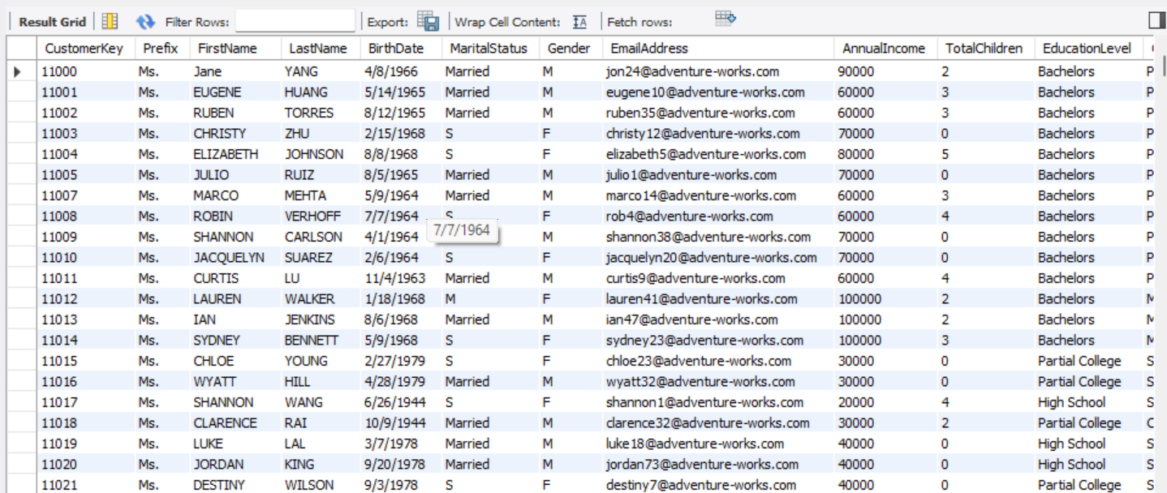

1. Write a query to calculate the average annual income of customers with a specific marital status and occupation combination (e.g., Married and Manager).

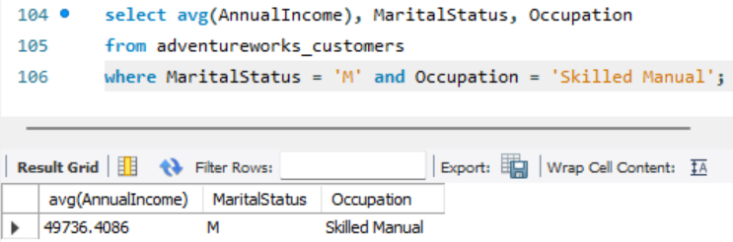

1. Create a query to sort customers by their occupation in descending order.



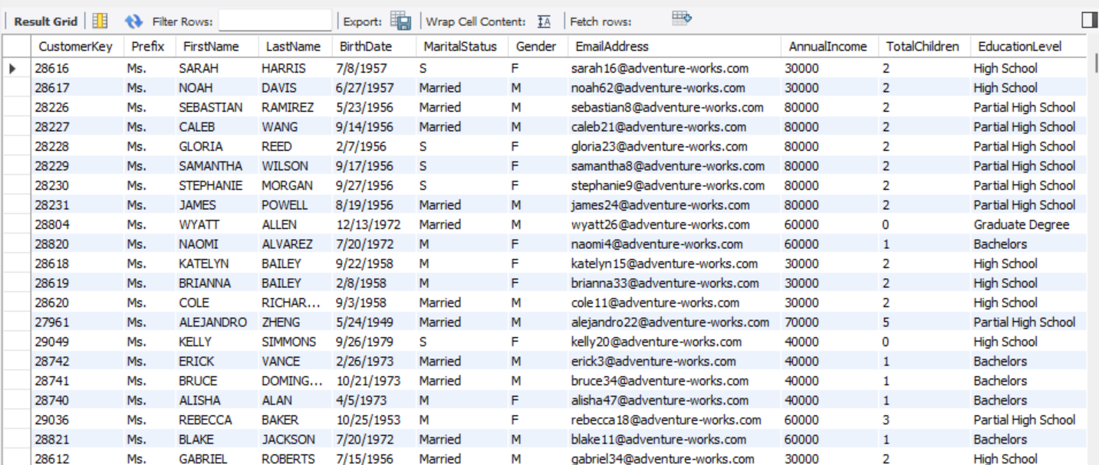

1. Write a query to find customers who were born on a specific date (e.g., January 1, 1980).



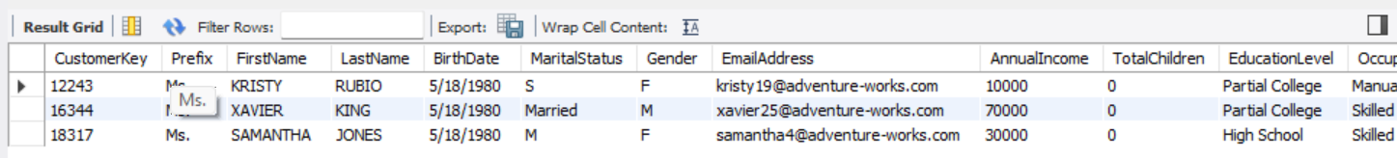

1. Create a query to count the number of customers with a specific first name and last name combination (e.g., Mary Johnson).

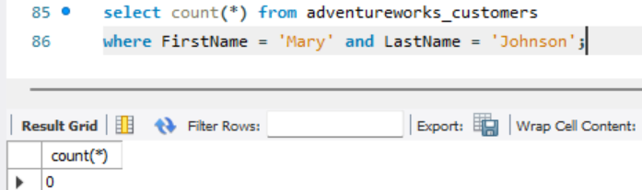

1. Write a query to find customers with a specific email address length (e.g., 10 characters).

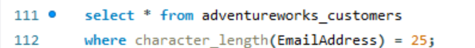

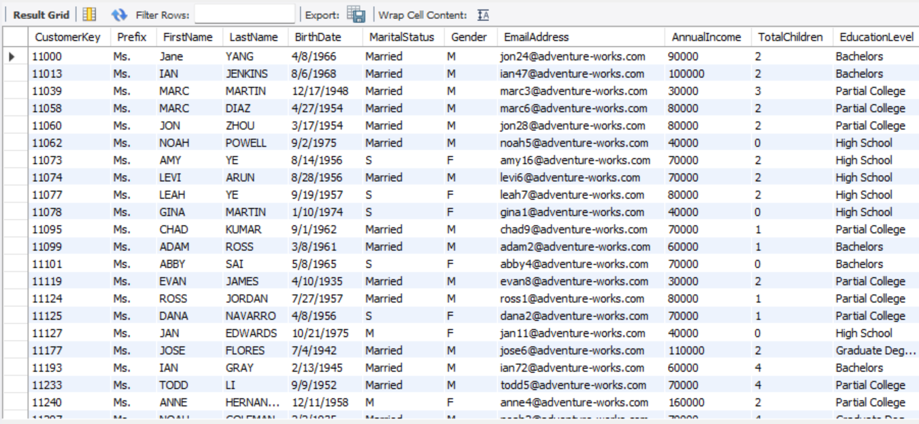

1. Create a query to calculate the total annual income of customers with a specific education level and occupation combination (e.g., Master's degree and Engineer).

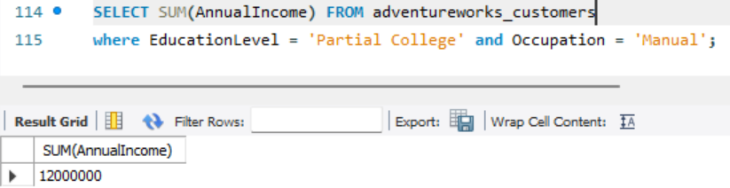

1. Write a query to find customers whose last name ends with a specific suffix (e.g., 'Jr.').

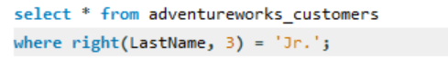



1. Create a query to sort customers by their annual income in ascending order.



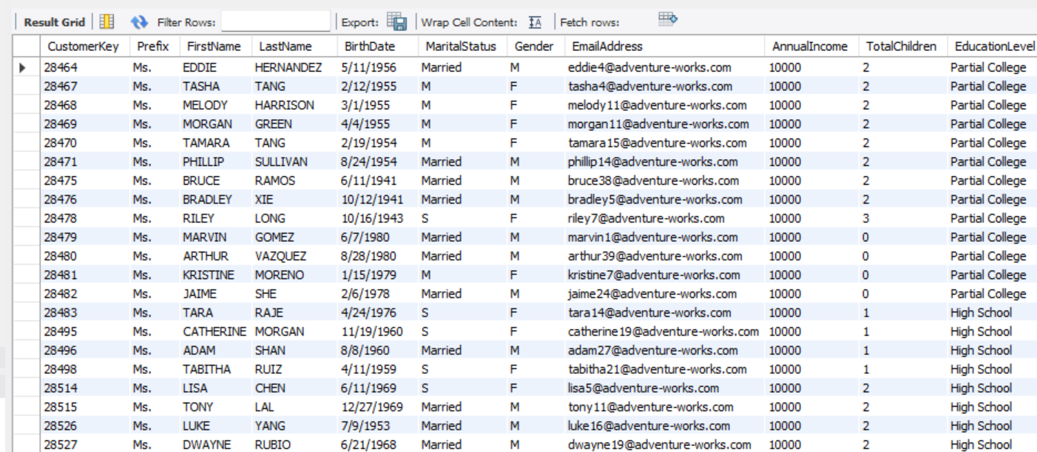

1. Write a query to identify customers with an even-numbered CustomerKey who were born in a specific month (e.g., June).



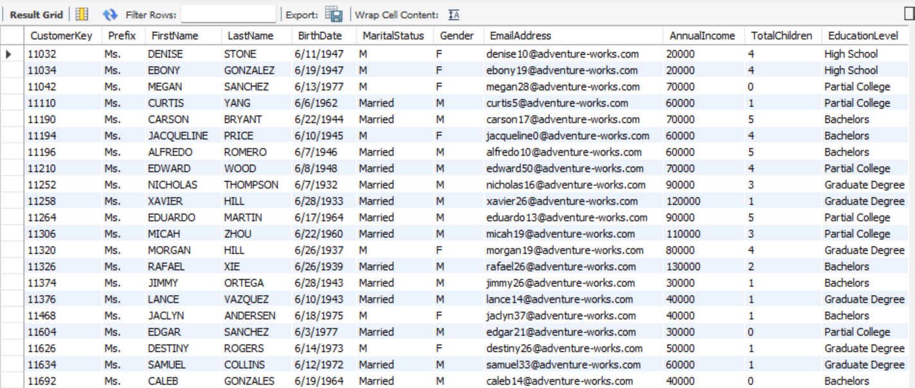

1. Create a query to calculate the average age of customers with a specific first name and marital status combination (e.g., Mark and Single).

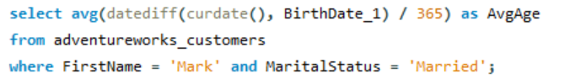

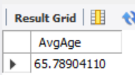

1. Write a query to find customers whose annual income contains a specific number (e.g., 7).

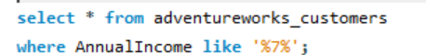

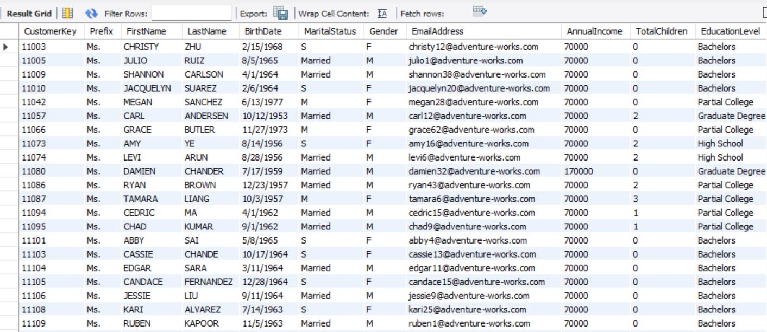

1. Create a query to count the number of customers with a specific occupation and education level combination (e.g., Sales Representative and Bachelor's degree).

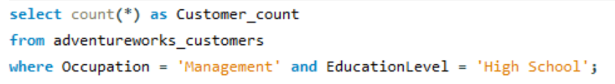

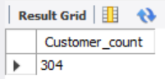

1. Write a query to find customers who were born before a specific date (e.g., January 1, 1990).

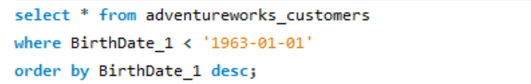

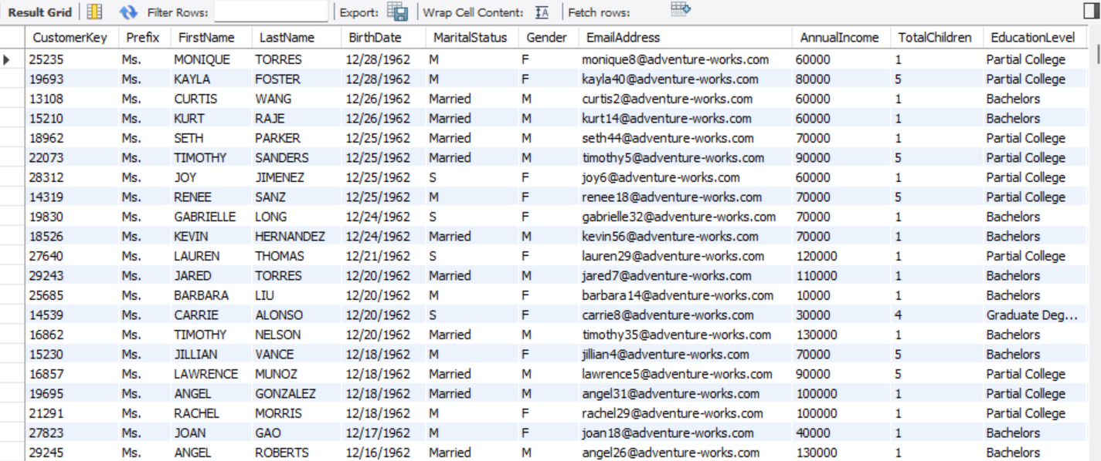

1. Create a query to sort customers by their total number of children in descending order.

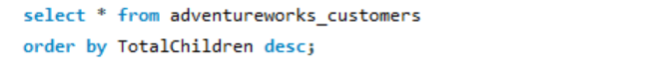

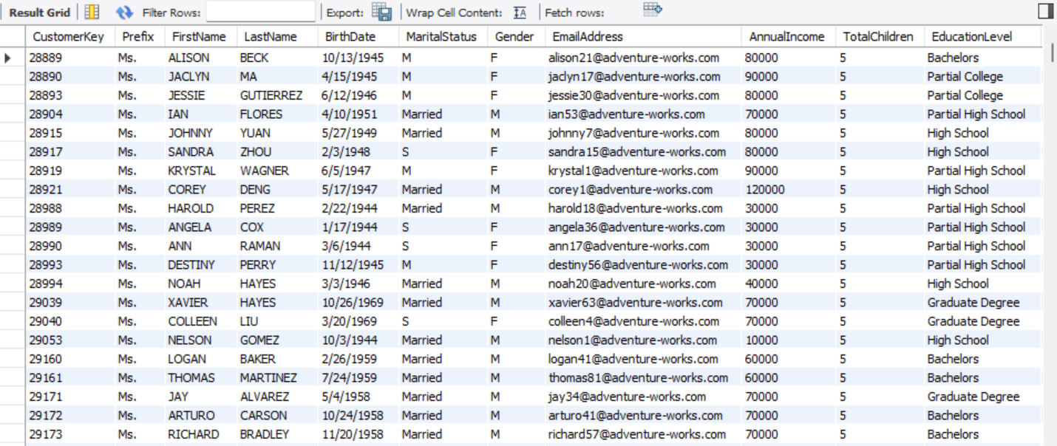

1. Write a query to calculate the average annual income of customers with a specific marital status and occupation combination (e.g., Married and Sales Representative).



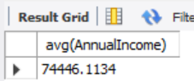

1. Create a query to identify customers who have made a purchase within a specific date range (e.g., January 1, 2020 - March 31, 2020). *Not Applicable*
2. Write a query to find customers whose first name contains a specific number of vowels (e.g., 2).

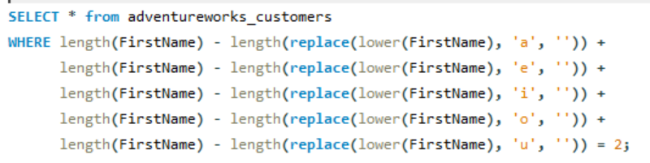

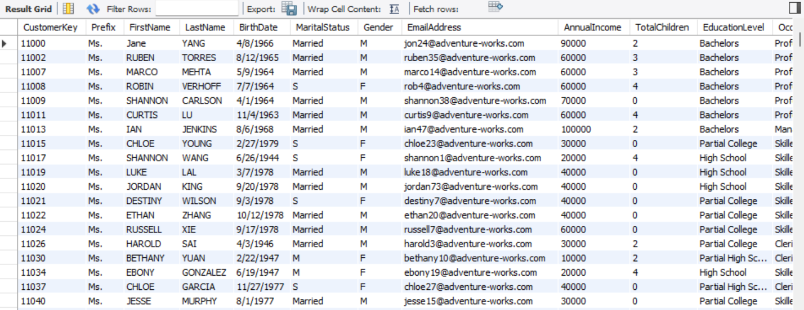

1. Create a query to count the number of customers with a specific gender and annual income range combination (e.g., Male and $75,000 - $100,000).

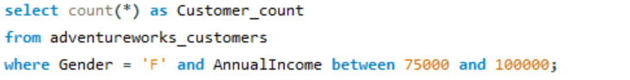

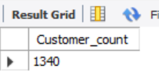

1. Write a query to sort customers by their education level in ascending order.

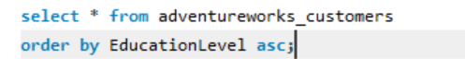

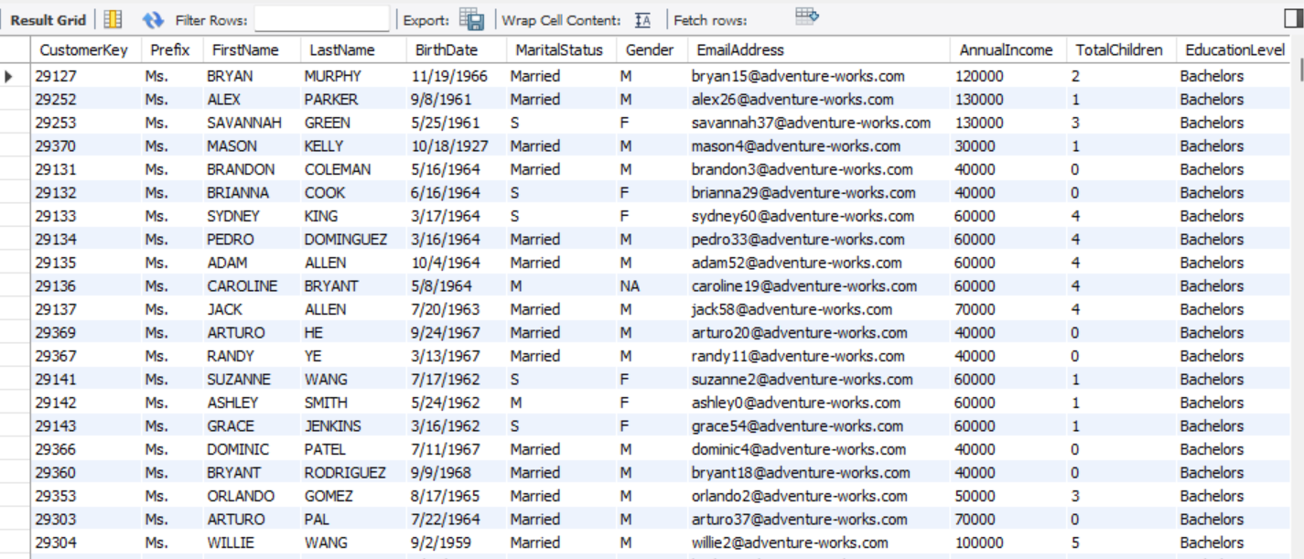

1. Create a query to calculate the total annual income of customers with a specific marital status and gender combination (e.g., Married and Female).



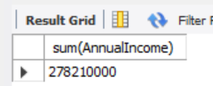

1. Write a query to find customers whose last name starts with a specific letter and ends with a specific letter (e.g., starts with 'S' and ends with 'n').



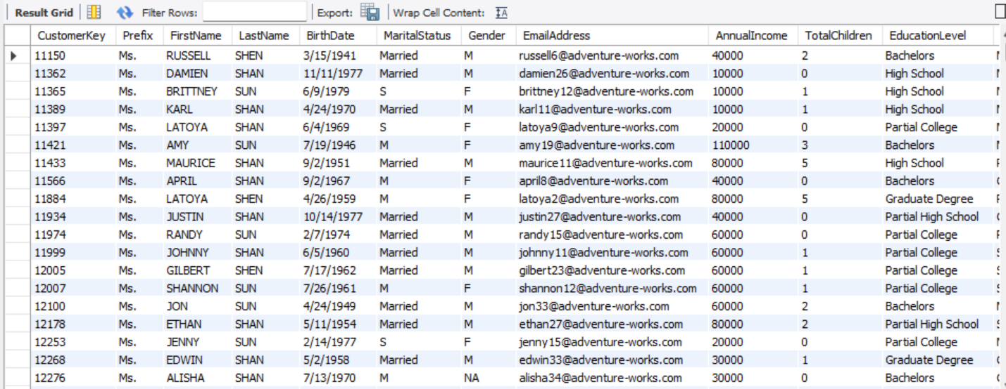

1. Create a query to identify customers who have made purchases from a specific store location. *Not Applicable*
2. Write a query to find customers with a specific number of characters in their email address (e.g., 15 characters).

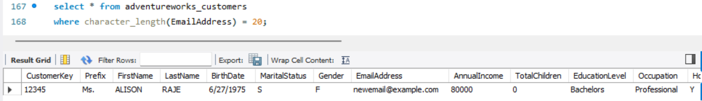

1. Create a query to calculate the average annual income of customers with a specific occupation and education level combination (e.g., Engineer and Master's degree).

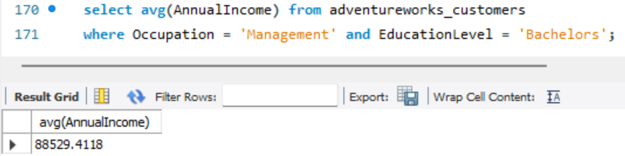

1. Write a query to sort customers by their annual income in descending order within each occupation category.

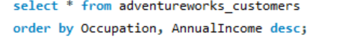

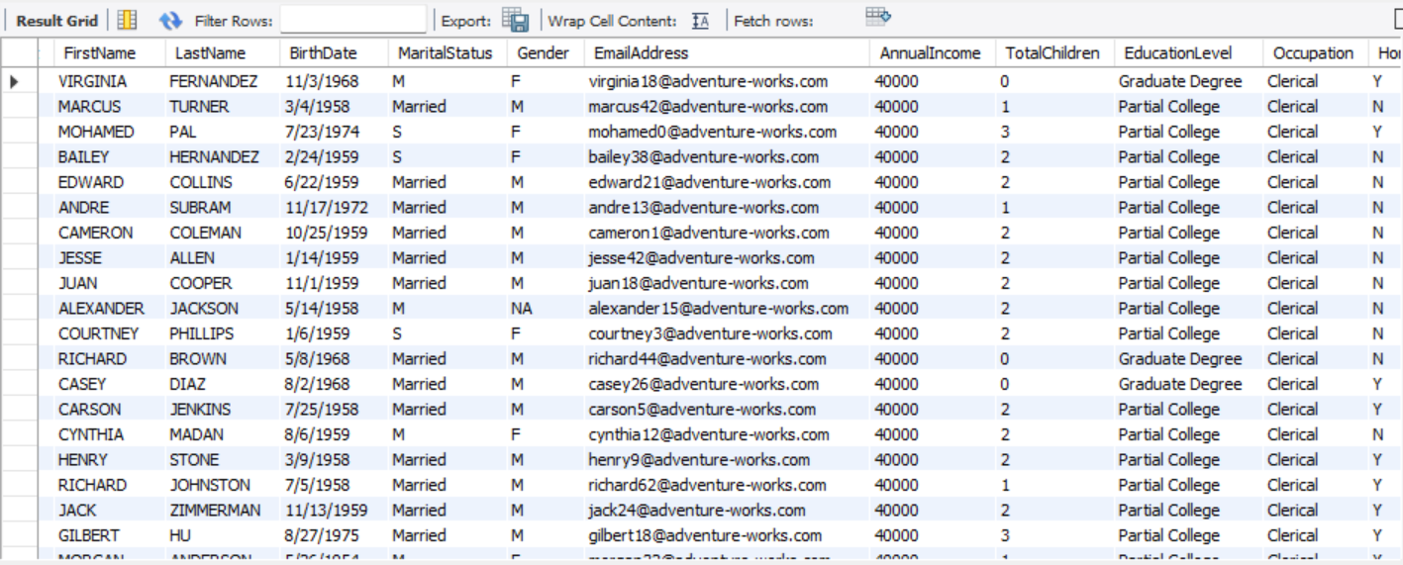

1. Create a query to find customers whose first name contains a specific consonant (e.g., 't').



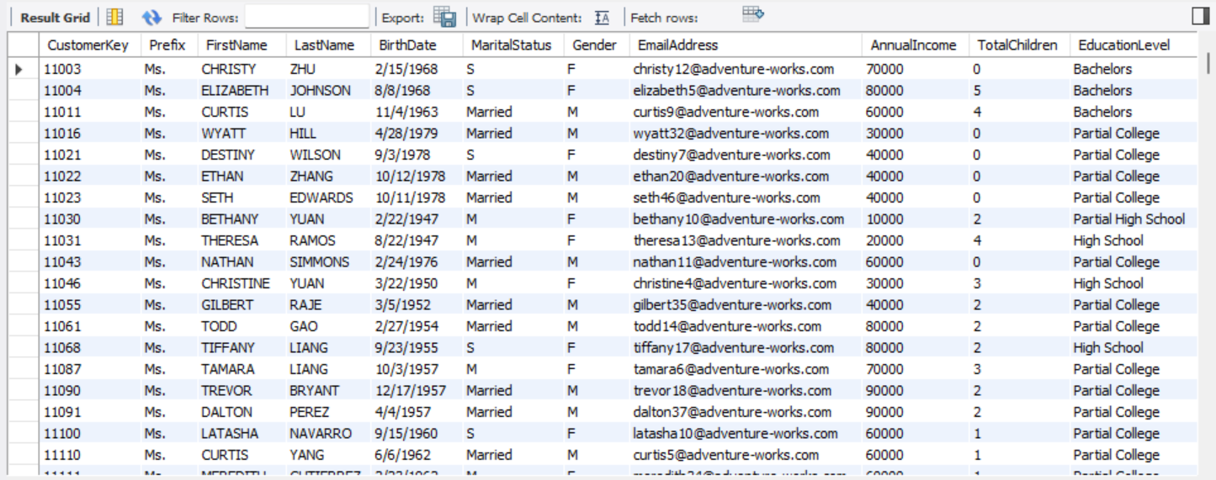

1. Write a query to calculate the total number of customers with a specific marital status and annual income range combination (e.g., Single and $50,000 - $75,000).

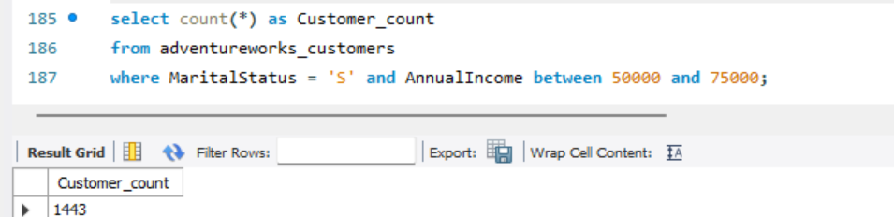

1. Create a query to find customers whose last name contains a specific number of syllables (e.g., 2 syllables).

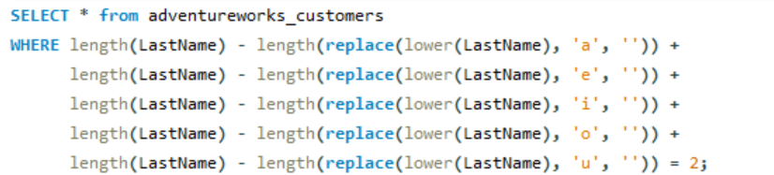

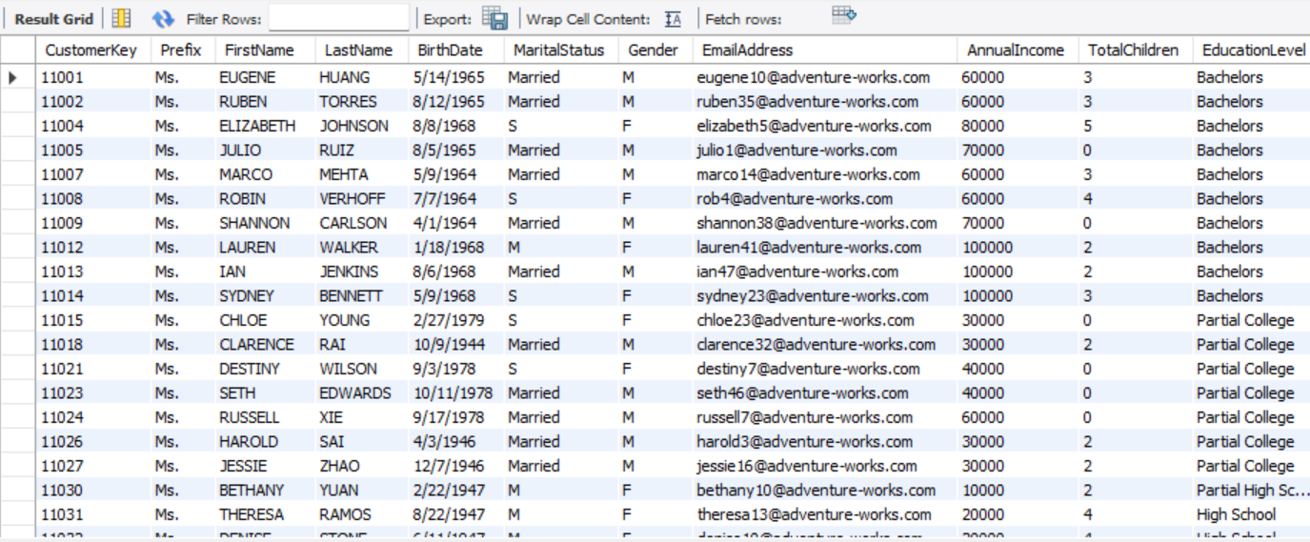

1. Write a query to sort customers by their birthdate in ascending order within each occupation category.

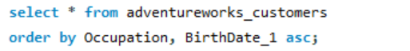

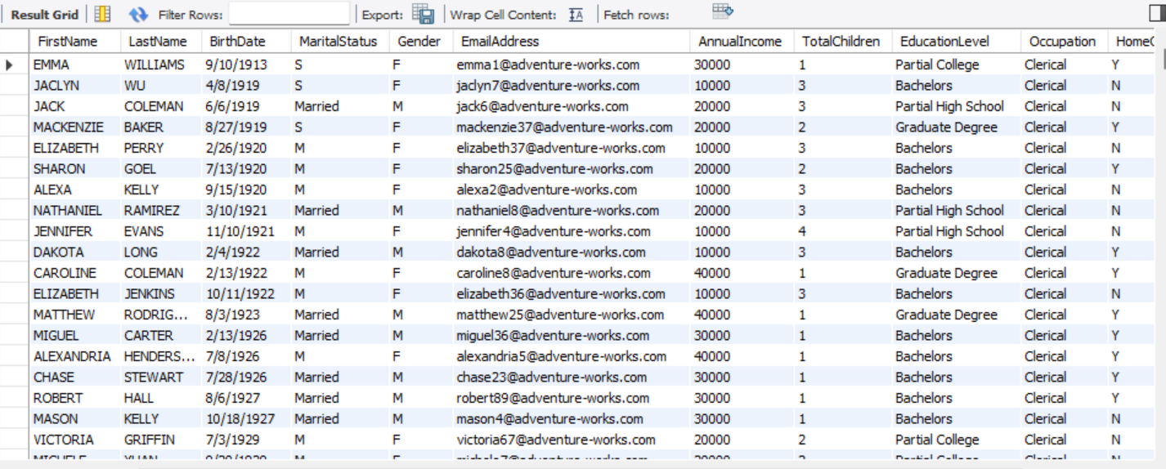

1. Create a query to calculate the average annual income of customers with a specific marital status and education level combination (e.g., Married and Bachelor's degree).

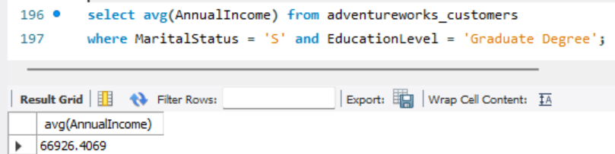

1. Write a query to find customers whose email address contains a specific special character (e.g., '@').



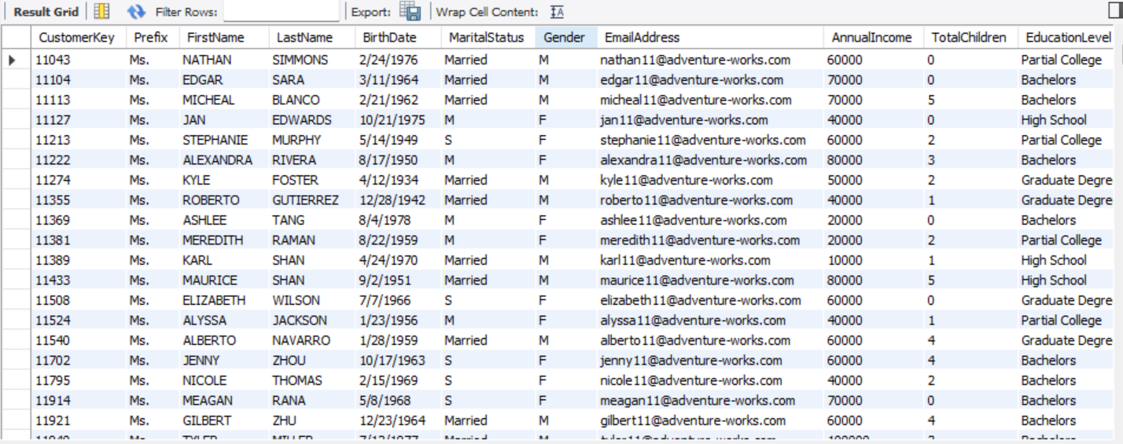

1. Create a query to identify customers who have made purchases from multiple store locations. *Not Applicable*
2. Write a query to calculate the total annual income of customers with a specific occupation and gender combination (e.g., Manager and Male).

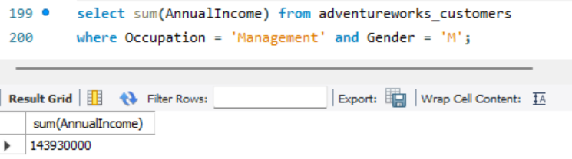

1. Create a query to find customers whose first name starts with a specific letter and ends with a specific letter (e.g., starts with 'A' and ends with 'a').

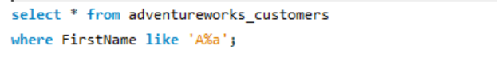

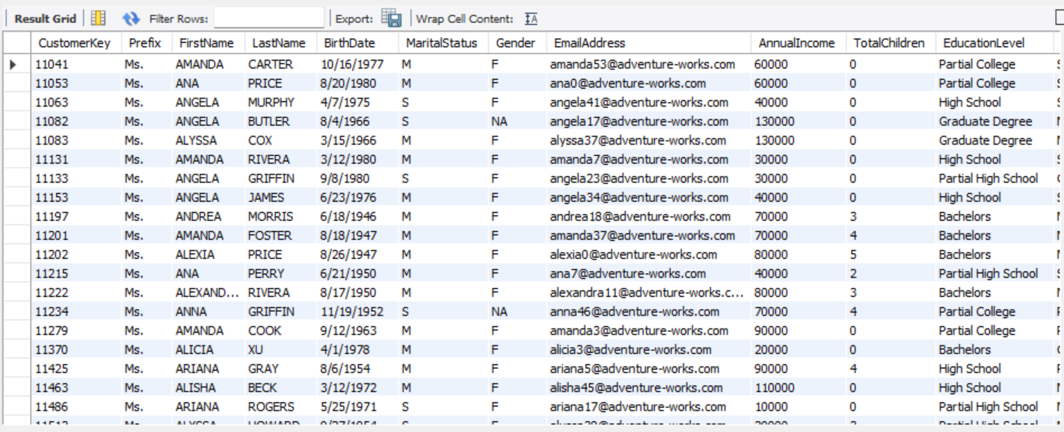

1. Write a query to sort customers by their total number of children in descending order within each marital status category.

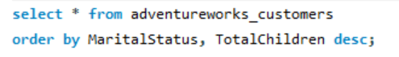

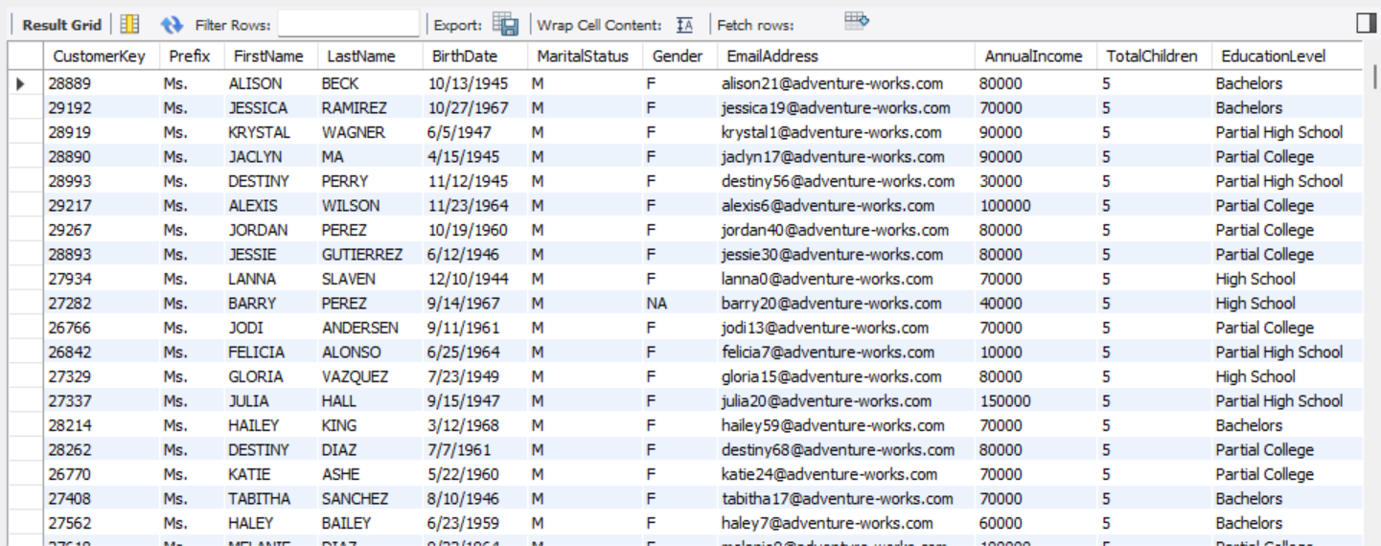

1. Create a query to calculate the average age of customers with a specific education level and gender combination (e.g., Master's degree and Female).

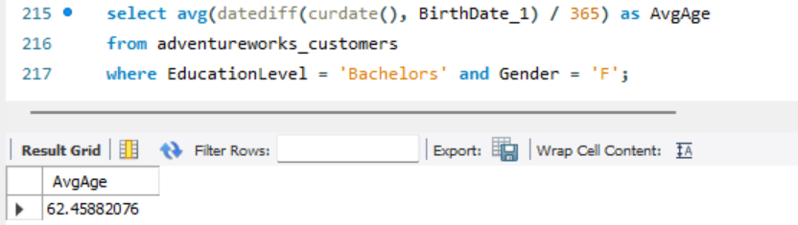

1. Write a query to find customers whose last name starts with a specific prefix (e.g., 'Mc').



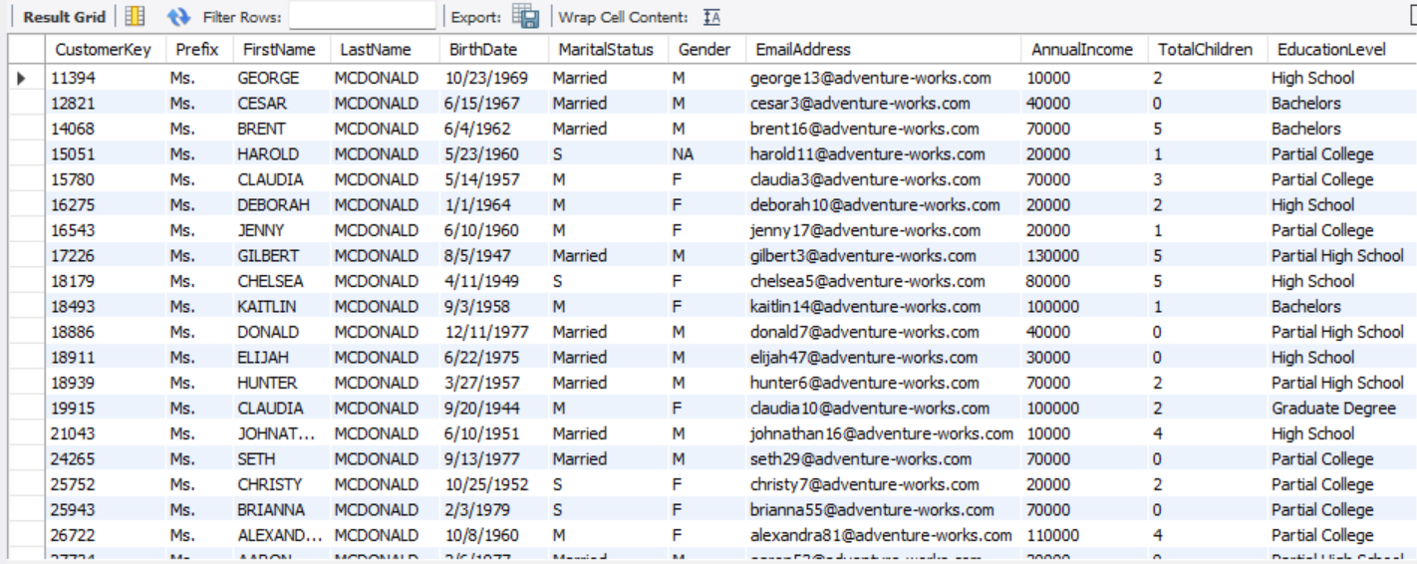

1. Create a query to identify customers who have made purchases of a specific product category (e.g., electronics). *Not Applicable*
2. Write a query to calculate the total annual income of customers with a specific marital status and education level combination (e.g., Single and Bachelor's degree).

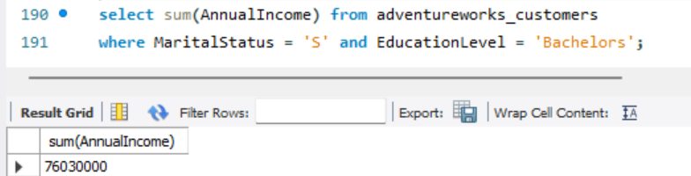

1. Create a query to find customers whose email address domain is a specific number of characters long (e.g., 10 characters).





1. Write a query to sort customers by their annual income in ascending order within each education level category.

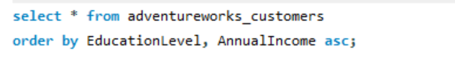

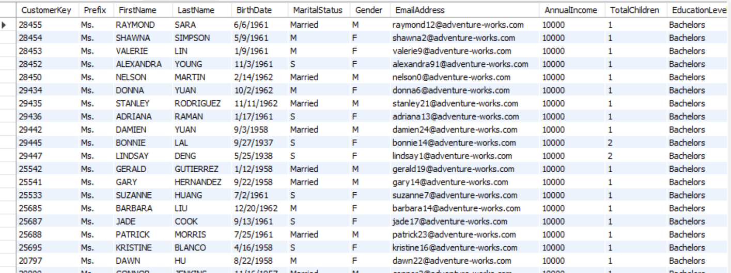

1. Create a query to calculate the average age of customers with a specific occupation and marital status combination (e.g., Engineer and Married).

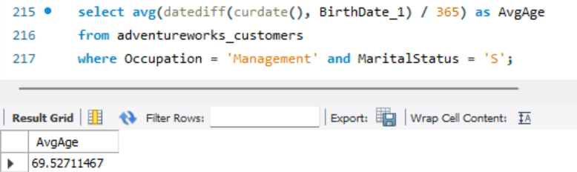

1. Write a query to find customers whose first name ends with a specific suffix (e.g., 'Jr.').





1. Create a query to identify customers who have made purchases on a specific day of the week (e.g., Sunday). *Not Applicable*